**i)**

# Extended 'Salaries and Wages' data with at least 30 values

salaries_wages <- c(388, 410, 444, 439, 437, 484, 553, 568, 495, 517, 583, 539, 546, 585, 629, 654, 759, 858, 990, 980, 725, 802, 876, 645, 910, 950, 600, 575, 620, 700)

# Select a sample of size n = 30

set.seed(123) # Set seed for reproducibility

sample_data <- sample(salaries_wages, 30)

# Define class intervals (adjust as needed)

class_intervals <- seq(floor(min(sample_data)), ceiling(max(sample_data)), by=50)

# Create frequency distribution

frequency_dist <- cut(sample_data, breaks=class_intervals, right=FALSE)

freq_table <- table(frequency_dist)

# Print the frequency distribution

print(freq_table)

# Plot the frequency distribution using base R (barplot)

barplot(freq_table,

col="lightblue",

main="Frequency Distribution of Salaries and Wages",

xlab="Salary Range",

ylab="Frequency",

border="black",

las=2) # las=2 makes the x-axis labels perpendicular for better readability

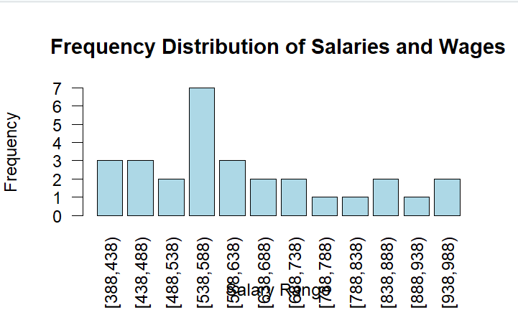output:

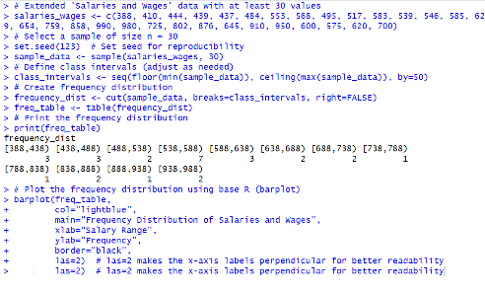

**ii)**

# Extended Salaries and Wages data

salaries_wages <- c(388, 410, 444, 439, 437, 484, 553, 568, 495, 517, 583, 539, 546, 585, 629, 654, 759, 858, 990, 980, 725, 802, 876, 645, 910, 950, 600, 575, 620, 700)

# Calculate statistical measures

mean_val <- mean(salaries_wages) # Mean

median_val <- median(salaries_wages) # Median

mode_val <- as.numeric(names(sort(table(salaries_wages), decreasing = TRUE)[1])) # Mode

sd_val <- sd(salaries_wages) # Standard Deviation

variance_val <- var(salaries_wages) # Variance

quartiles <- quantile(salaries_wages) # Quartiles

decile_9 <- quantile(salaries_wages, probs = 0.9) # 9th Decile

percentile_10 <- quantile(salaries_wages, probs = 0.1) # 10th Percentile

range_val <- range(salaries_wages) # Range

range_diff <- diff(range_val)

# Display results

cat("Mean:", mean_val, "\n")

cat("Median:", median_val, "\n")

cat("Mode:", mode_val, "\n")

cat("Standard Deviation:", sd_val, "\n")

cat("Variance:", variance_val, "\n")

cat("Quartiles:\n")

print(quartiles)

cat("9th Decile:", decile_9, "\n")

cat("10th Percentile:", percentile_10, "\n")

cat("Range:", range_val, "\n")

cat("Range Difference:", range_diff, "\n")

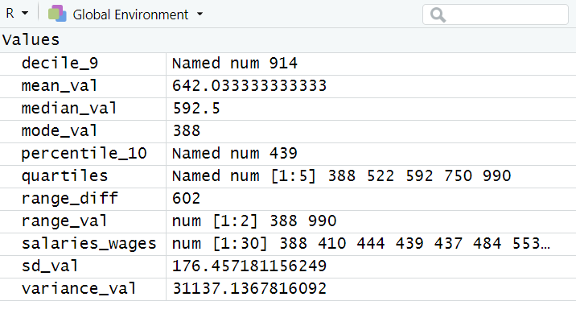output:

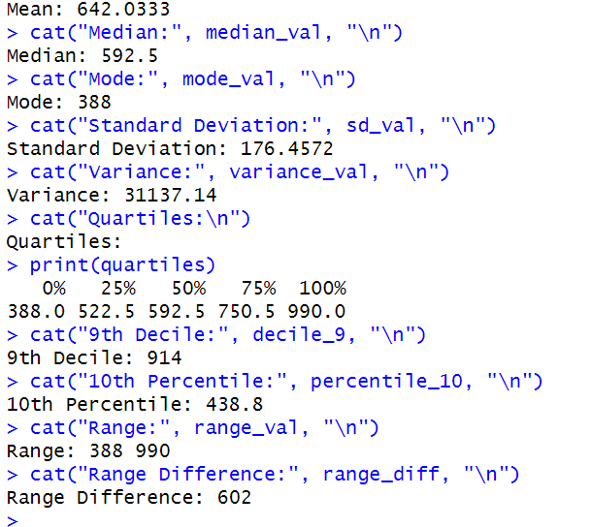**iii)**

# Salaries and Wages data

salaries_wages <- c(388, 410, 444, 439, 437, 484, 553, 568, 371, 327, 292, 293, 296, 325, 354, 358, 367, 414, 528, 615, 649)

# Set the sample size

sample_size <- 30

# Ensure reproducibility

set.seed(123) # Replace 123 with any other number for a different random sample

# Select a random sample with replacement

sample_data <- sample(salaries_wages, size = sample_size, replace = TRUE)# Extended Salaries and Wages data

salaries_wages <- c(388, 410, 444, 439, 437, 484, 553, 568, 495, 517, 583, 539, 546, 585, 629, 654, 759, 858, 990, 980, 725, 802, 876, 645, 910, 950, 600, 575, 620, 700)

# Calculate the range of data

data_range <- range(salaries_wages)

range_diff <- diff(data_range)

# Determine the number of bins using Sturges' formula

num_bins <- ceiling(1 + log2(length(salaries_wages)))

# Calculate bin width

bin_width <- ceiling(range_diff / num_bins)

# Create breakpoints for bins

breaks <- seq(data_range[1], data_range[2] + bin_width, by = bin_width)

# Plot the histogram

hist(

salaries_wages,

breaks = breaks,

col = "skyblue",

border = "black",

main = "Histogram of Grouped Salaries",

xlab = "Salaries and Wages (Grouped)",

ylab = "Frequency",

right = FALSE

)

# Display the selected sample

cat("Selected Sample (Size 30):\n")

print(sample_data)

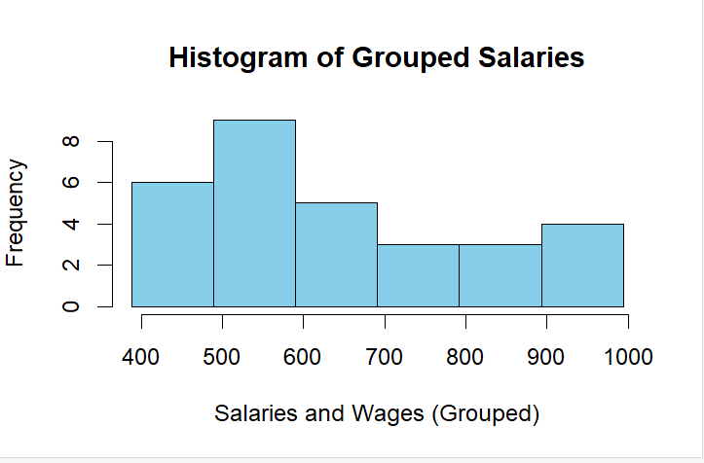

**iv)**

# Salaries and Wages data

salaries_wages <- c(388, 410, 444, 439, 437, 484, 553, 568, 371, 327, 292, 293, 296, 325, 354, 358, 367, 414, 528, 615, 649)

# Set the sample size

sample_size <- 30

# Ensure reproducibility

set.seed(123) # Replace 123 with any other number for a different random sample

# Select a random sample with replacement

sample_data <- sample(salaries_wages, size = sample_size, replace = TRUE)# Extended Salaries and Wages data

salaries_wages <- c(388, 410, 444, 439, 437, 484, 553, 568, 495, 517, 583, 539, 546, 585, 629, 654, 759, 858, 990, 980, 725, 802, 876, 645, 910, 950, 600, 575, 620, 700)

# Calculate the range of data

data_range <- range(salaries_wages)# Maintenance data

maintenance <- c(552, 588, 696, 737, 788, 757, 808, 710, 594, 553, 614, 721, 833, 750, 712, 913, 1103, 961, 993, 1076, 774)

# Load Factor data

load_factor <- c(67.6, 69.6, 69.6, 70.1, 68.3, 69.6, 69.4, 71.2, 75.4, 77.7, 80.8, 81.8, 82.6, 82.2, 81.8, 83.0, 84.5, 83.1, 84.4, 85.4, 85.5)

# Names for categories (optional, based on your requirement)

categories <- paste("Observation", 1:length(maintenance))

# Pie Chart for Maintenance

pie(

maintenance,

labels = categories,

main = "Pie Chart for Maintenance",

col = rainbow(length(maintenance))

)

# Bar Diagram for Maintenance

barplot(

maintenance,

names.arg = categories,

main = "Bar Diagram for Maintenance",

col = "skyblue",

xlab = "Observations",

ylab = "Maintenance Costs ($)",

las = 2

)

# Pie Chart for Load Factor

pie(

load_factor,

labels = categories,

main = "Pie Chart for Load Factor",

col = rainbow(length(load_factor))

)

# Bar Diagram for Load Factor

barplot(

load_factor,

names.arg = categories,

main = "Bar Diagram for Load Factor",

col = "lightgreen",

xlab = "Observations",

ylab = "Load Factor (%)",

las = 2

)

Output:

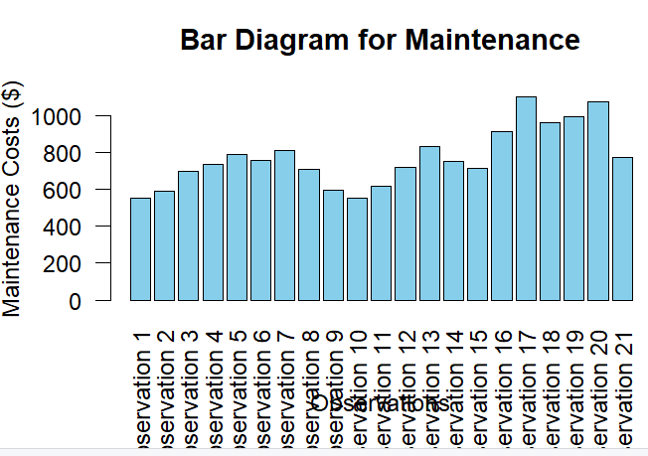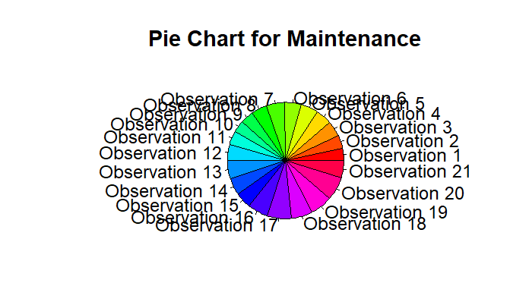

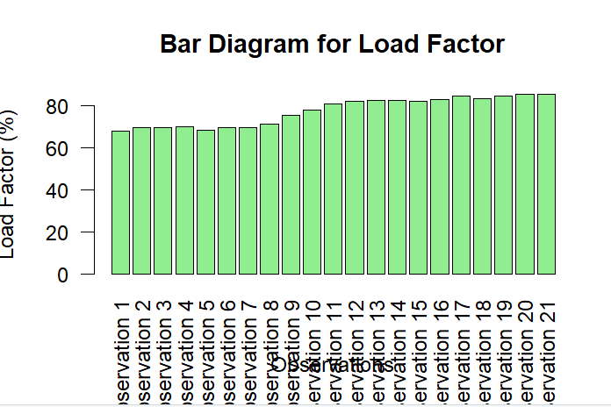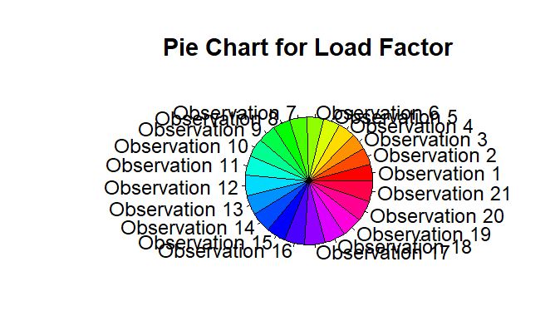

**v)**

# Data for Purchased Goods, Aircraft Ownership, and Daily Utilization per Aircraft

purchased_goods <- c(644, 784, 756, 650, 631, 864, 961, 873, 1021, 1354, 1897, 2200, 2236, 3644, 1844, 2478, 3124, 3166, 2951, 2775, 1836)

aircraft_ownership <- c(445, 411, 387, 396, 408, 444, 485, 512, 399, 358, 315, 366, 391, 414, 435, 379, 229, 295, 280, 293, 291)

daily_utilization <- c(9.28, 9.40, 9.59, 9.78, 9.95, 9.85, 9.22, 8.96, 9.00, 9.81, 10.36, 10.57, 10.65, 9.96, 10.23, 10.46, 10.39, 10.01, 10.07, 9.65, 9.18)

# Combine data into a data frame

data <- data.frame(

Purchased_Goods = purchased_goods,

Aircraft_Ownership = aircraft_ownership,

Daily_Utilization = daily_utilization

)

# Plot box plots

par(mfrow = c(1, 3)) # Set layout to display multiple plots in a row

# Box plot for Purchased Goods

boxplot(

data$Purchased_Goods,

main = "Box Plot: Purchased Goods",

col = "lightblue",

ylab = "Cost ($)"

)

# Box plot for Aircraft Ownership

boxplot(

data$Aircraft_Ownership,

main = "Box Plot: Aircraft Ownership",

col = "lightgreen",

ylab = "Cost ($)"

)

# Box plot for Daily Utilization

boxplot(

data$Daily_Utilization,

main = "Box Plot: Daily Utilization",

col = "lightpink",

ylab = "Hours"

)

# Reset plot layout

par(mfrow = c(1, 1))

output:

